Circumference
# Source: AI Source: Provided by: [Data Path: Persons Table -> ID Column: 1, Name_En Column: Motasem Essam] -> From: [ChatGPT] on [7/25/2026]
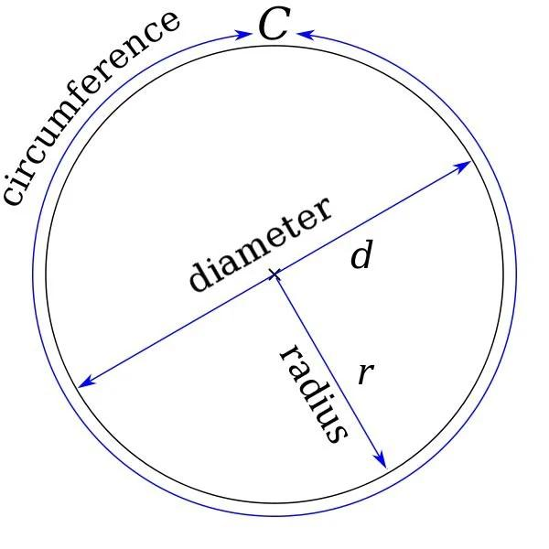
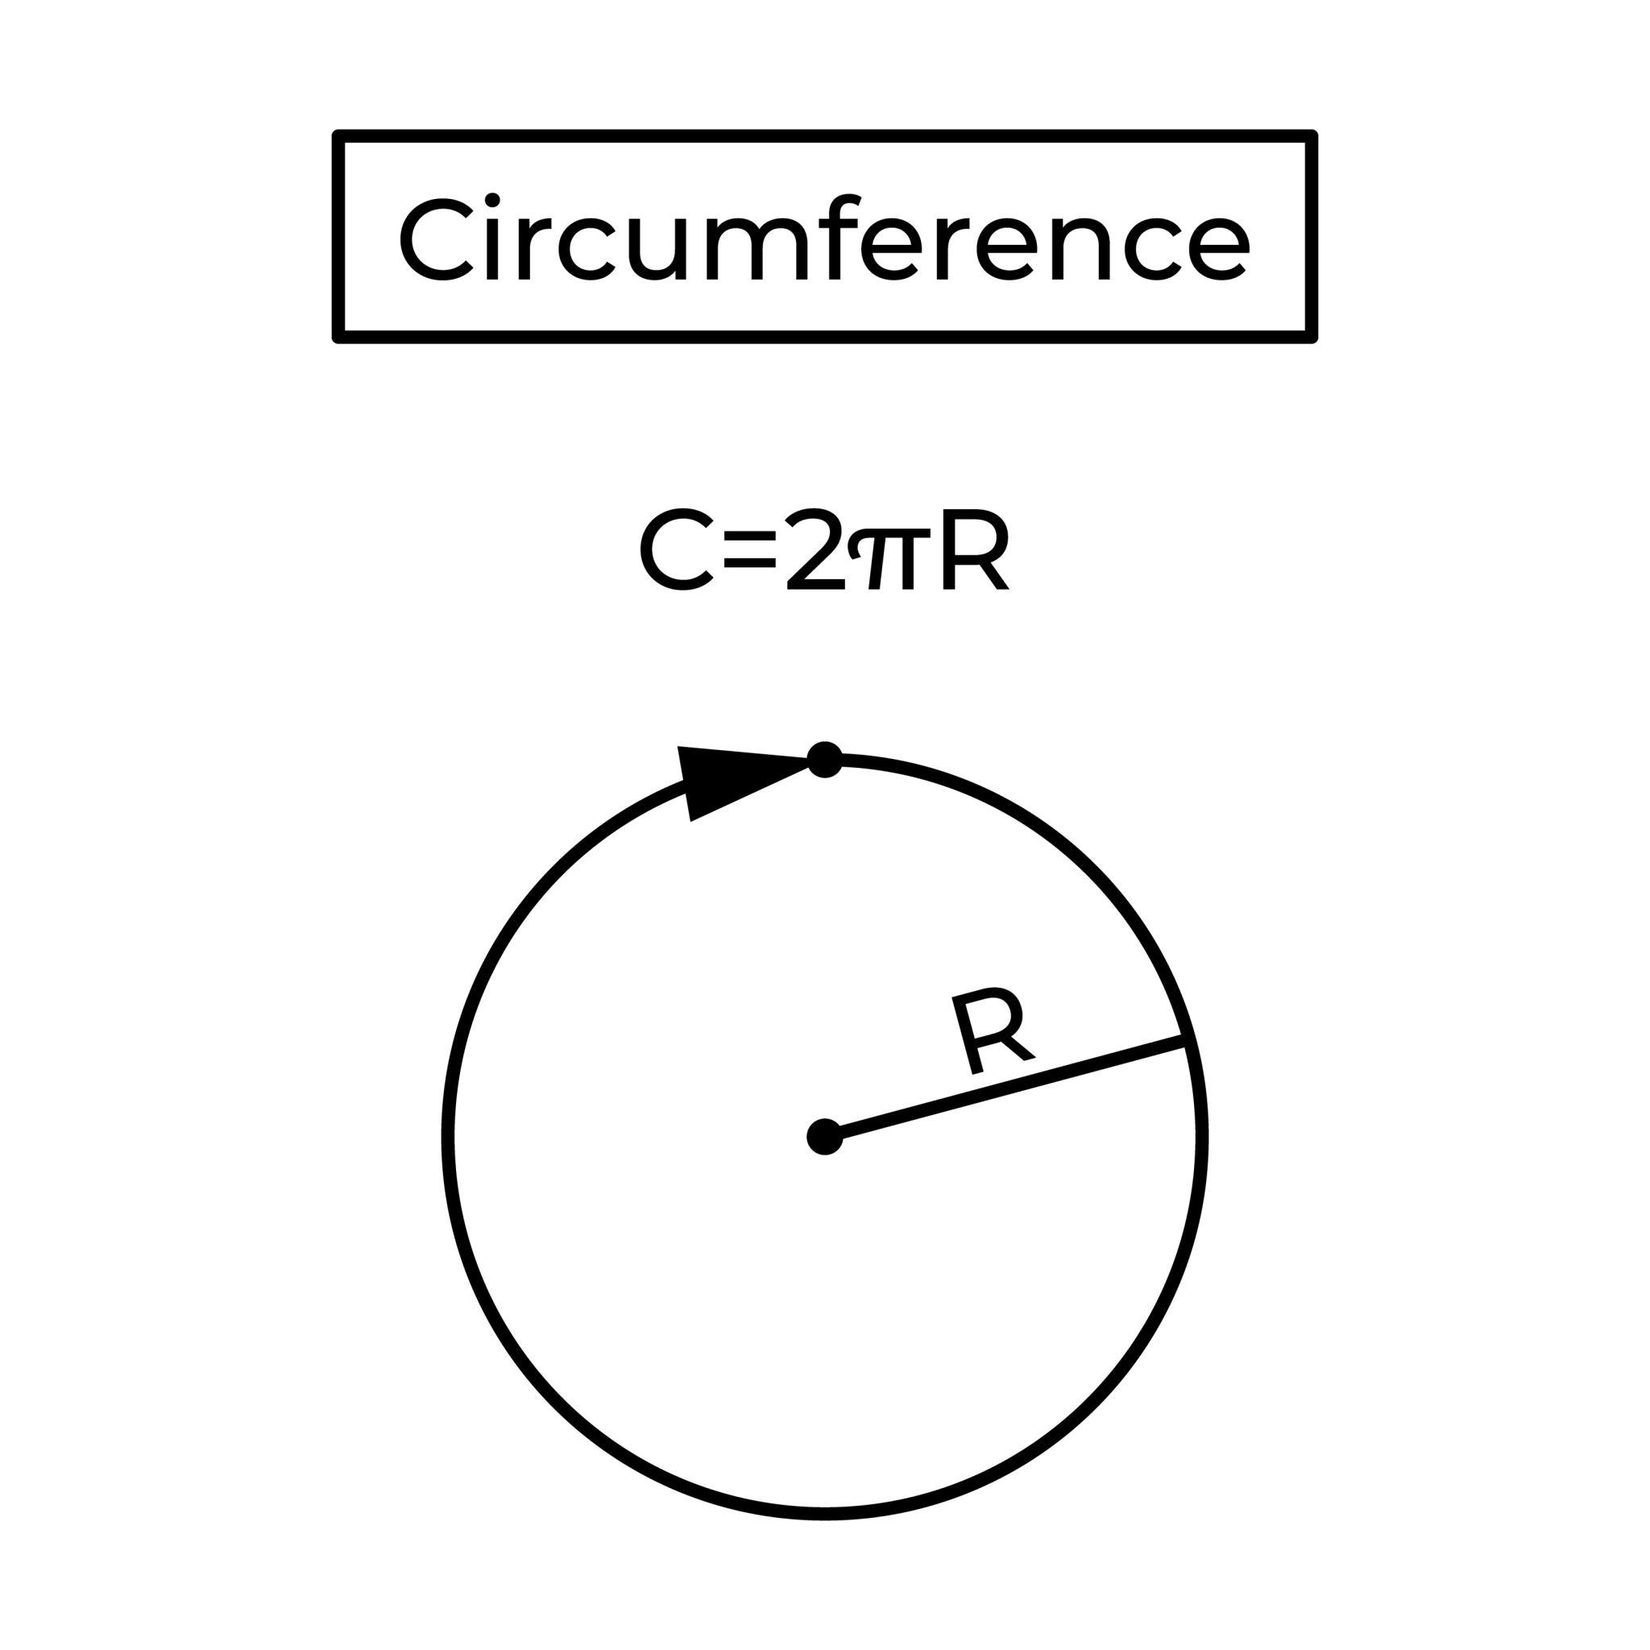
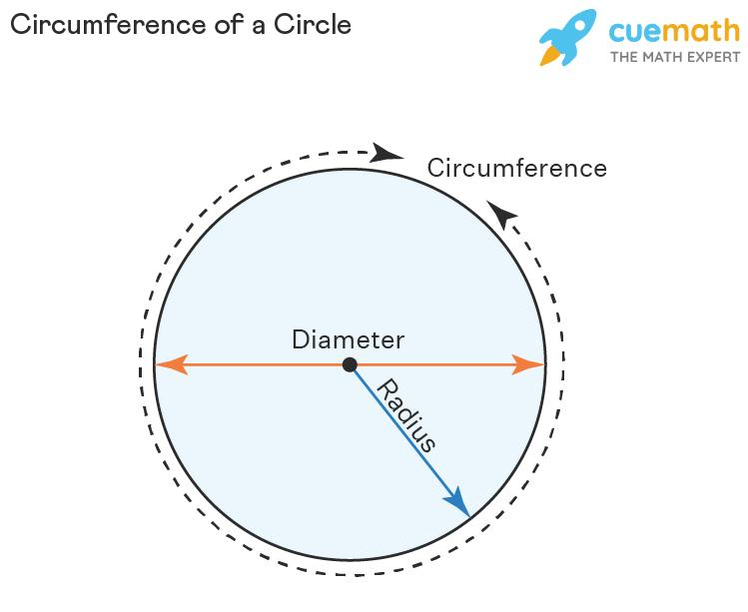
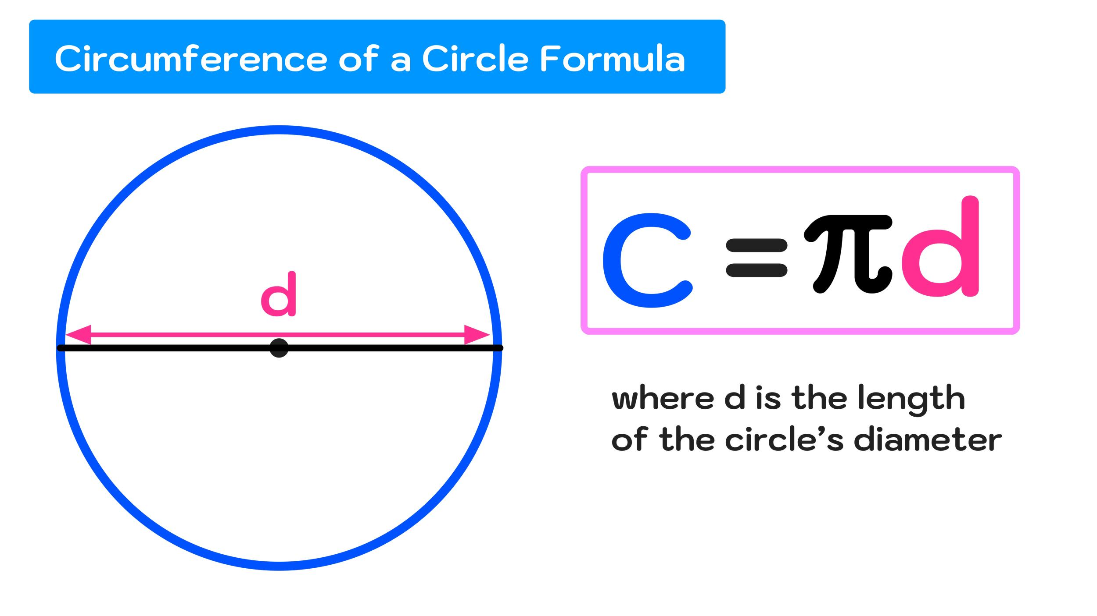
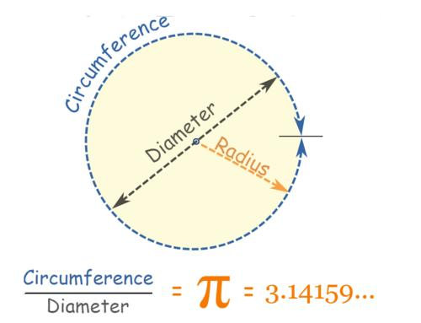

Definition
# Source: AI Source: Provided by: [Data Path: Persons Table -> ID Column: 1, Name_En Column: Motasem Essam] -> From: [ChatGPT] on [7/25/2026]
The circumference is the distance around the boundary of a circle.
It is the circular counterpart of the perimeter of a polygon.
The circumference is usually denoted by:
$$\boxed{C}$$

Fundamental Elements
# Source: AI Source: Provided by: [Data Path: Persons Table -> ID Column: 1, Name_En Column: Motasem Essam] -> From: [ChatGPT] on [7/25/2026]

Circle
├── Center
├── Radius
├── Diameter
└── Circumference
└── Circular boundary
The circumference is the boundary itself, while $C$represents its length.

Mathematical Representation
# Source: AI Source: Provided by: [Data Path: Persons Table -> ID Column: 1, Name_En Column: Motasem Essam] -> From: [ChatGPT] on [7/25/2026]
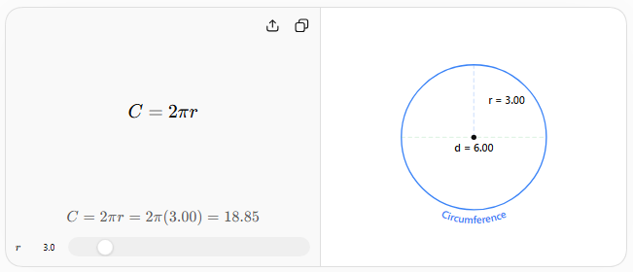
If $r$ is the radius:
$$\boxed{C=2πr}$$
Since:
$$d=2r$$
the circumference can also be written as:
$$\boxed{C=πd}$$
where:
- $C$= circumference
- $r$= radius
- $d$= diameter
- $π≈3.14159$

Example 1 — Using Radius
# Source: AI Source: Provided by: [Data Path: Persons Table -> ID Column: 1, Name_En Column: Motasem Essam] -> From: [ChatGPT] on [7/25/2026]
If:
$$r=5\text{ cm}$$
then:
$$C=2π\left(5\right) \\ \boxed{C=10π\text{ cm}}$$
Approximately:
$$\boxed{C≈31.42\text{ cm}}$$

Example 2 — Using Diameter
# Source: AI Source: Provided by: [Data Path: Persons Table -> ID Column: 1, Name_En Column: Motasem Essam] -> From: [ChatGPT] on [7/25/2026]
If:
$$d=12\text{ m}$$
then:
$$C=πd \\ \boxed{C=12π\text{ m}}$$
Approximately:
$$\boxed{C≈37.70\text{ m}}$$

Circumference vs Perimeter
# Source: AI Source: Provided by: [Data Path: Persons Table -> ID Column: 1, Name_En Column: Motasem Essam] -> From: [ChatGPT] on [7/25/2026]

Concept | Shape | Meaning
Circumference | Circle | Distance around a circle
Perimeter | Polygon/closed shape | Total distance around its boundary
Thus, circumference can be considered the perimeter of a circle.

Relationship with Radius and Diameter
# Source: AI Source: Provided by: [Data Path: Persons Table -> ID Column: 1, Name_En Column: Motasem Essam] -> From: [ChatGPT] on [7/25/2026]
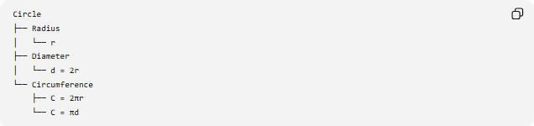
Circle
├── Radius
│ └── r
├── Diameter
│ └── d = 2r
└── Circumference
├── C = 2πr
└── C = πd
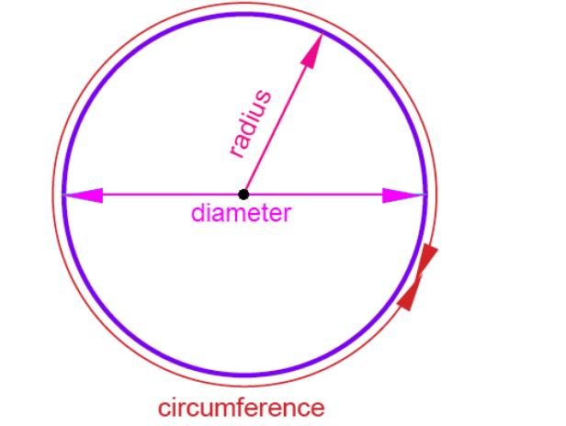
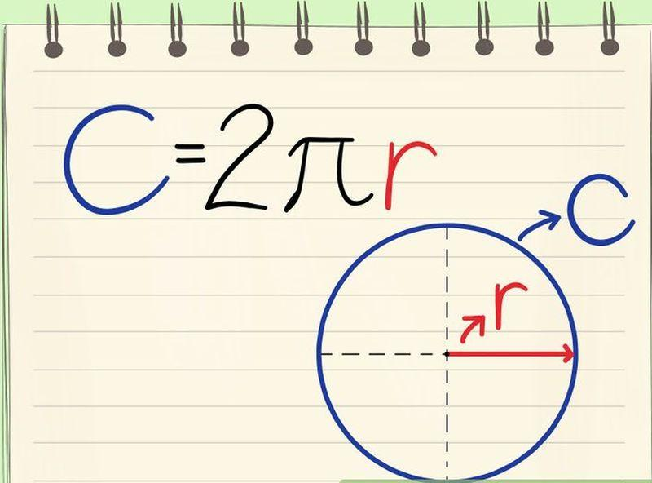
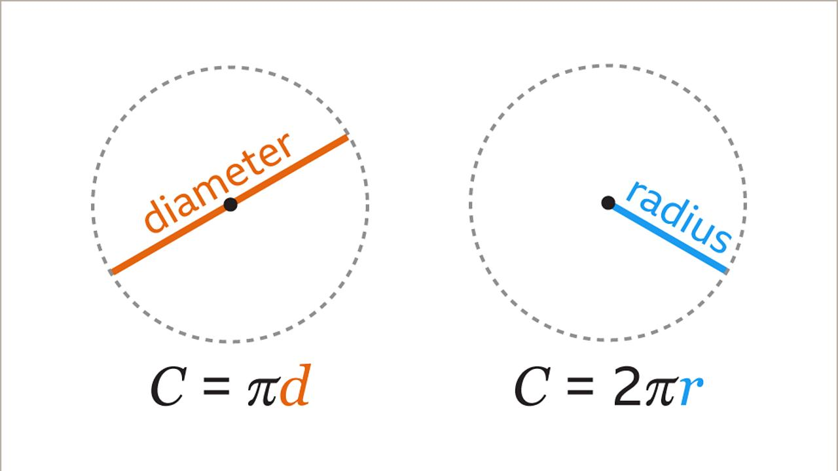
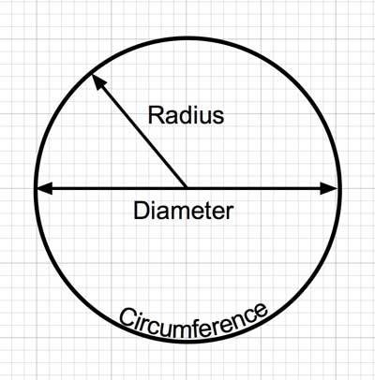

Relationship with Arc
# Source: AI Source: Provided by: [Data Path: Persons Table -> ID Column: 1, Name_En Column: Motasem Essam] -> From: [ChatGPT] on [7/25/2026]
An arc is a portion of the circumference.

Circumference
├── Minor Arc
├── Semicircular Arc
└── Major Arc
The entire circumference corresponds to:
$${360}^{∘}$$
For an arc with central angle $θ$:
$$\boxed{L=\frac{θ}{{360}^{∘}}C}$$
or:
$$\boxed{L=\frac{θ}{{360}^{∘}}\left(2πr\right)}$$
where $L$is the arc length.

Special Relationships

Circumference and Diameter
# Source: AI Source: Provided by: [Data Path: Persons Table -> ID Column: 1, Name_En Column: Motasem Essam] -> From: [ChatGPT] on [7/25/2026]
The ratio of circumference to diameter is always $π$:
$$\boxed{\frac{C}{d}=π}$$
Therefore:
$$\boxed{π=\frac{C}{d}}$$
This relationship is fundamental to the definition of $π$.

Circumference and Radius
# Source: AI Source: Provided by: [Data Path: Persons Table -> ID Column: 1, Name_En Column: Motasem Essam] -> From: [ChatGPT] on [7/25/2026]
Because $d=2r$:
$$\boxed{C=2πr}$$
Therefore:
$$\boxed{r=\frac{C}{2π}}$$

Units
# Source: AI Source: Provided by: [Data Path: Persons Table -> ID Column: 1, Name_En Column: Motasem Essam] -> From: [ChatGPT] on [7/25/2026]
Circumference is a length, so it uses units such as:
- millimeters (mm)
- centimeters (cm)
- meters (m)
- kilometers (km)
- inches (in)
- feet (ft)
If the radius is measured in centimeters, the circumference is also measured in centimeters.

Real-World Applications
# Source: AI Source: Provided by: [Data Path: Persons Table -> ID Column: 1, Name_En Column: Motasem Essam] -> From: [ChatGPT] on [7/25/2026]
Circumference is used when calculating distances around circular objects, such as:
- wheels
- gears
- circular tracks
- pipes
- circular tables
- rotating machinery
- cylindrical objects

Example
# Source: AI Source: Provided by: [Data Path: Persons Table -> ID Column: 1, Name_En Column: Motasem Essam] -> From: [ChatGPT] on [7/25/2026]
A wheel has a diameter of $70\text{ cm}$.
The distance traveled in one complete rotation is:
$$C=πd \\ C=70π \\ \boxed{C≈219.91\text{ cm}}$$
So one complete rotation moves the wheel approximately $2.20$meters.

Key Points
# Source: AI Source: Provided by: [Data Path: Persons Table -> ID Column: 1, Name_En Column: Motasem Essam] -> From: [ChatGPT] on [7/25/2026]
- Circumference = distance around a circle.
- It is the length of the circle's boundary.
- Formula using radius:
$$\boxed{C=2πr}$$
- Formula using diameter:
$$\boxed{C=πd}$$
- The circumference corresponds to ${360}^{∘}$.
- An arc is a portion of the circumference.
- Circumference is the circular equivalent of perimeter.

Conclusion
# Source: AI Source: Provided by: [Data Path: Persons Table -> ID Column: 1, Name_En Column: Motasem Essam] -> From: [ChatGPT] on [7/25/2026]
The circumference measures the complete distance around a circle. It is directly related to the radius and diameter through the constant $π$, making it one of the fundamental measurements of circular geometry.
$$\boxed{C=2πr=πd}$$

